# Cancel Repayment Agreement

Step 1: Access the Resident Profile  
Go to the Residents section, select All Residents, and choose the specific resident whose repayment agreement you wish to cancel. You can also use the quick search bar on the top right to search for a resident.

Step 2: Locate the Repayment Agreement  
In the resident’s profile, navigate to the **Financial** section, then select **Ledger**. From there, go to the **Repayments** side tab and click on the ID number of the repayment agreement you want to cancel.

Step 3: Initiate the Cancellation  
Once in the repayment agreement details, click on the **Cancel Repayment Agreement** button located in the top-right corner.

Step 4: Confirm the Cancellation  
Review the information, and when ready, click **Submit** to finalize the cancellation of the Repayment Agreement.

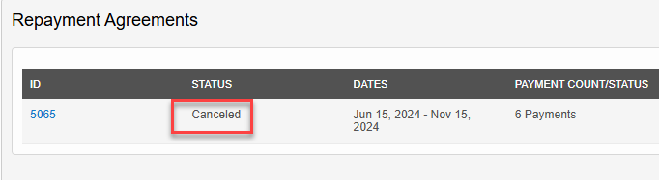

## Step 5: Write-Off Charges to Bad Debt and Send Account to Collections

Note: For more detailed information on the process of sending an account to collections, refer to the **Sending an Account to Collections** document.

